**Group 762**

Matei Oprea, Mario Zaja, Anubhav Sabharwal, Volodymyr Myagkov

1: electrical circuit model (Inductor: L, ESR, Capacitor: C, ESR, ESL)

Capacitor: Inductor:

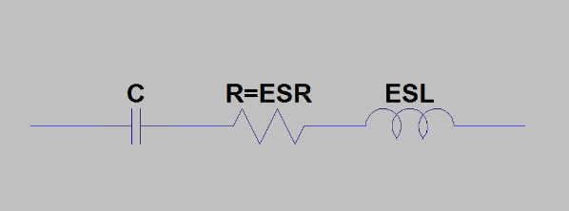 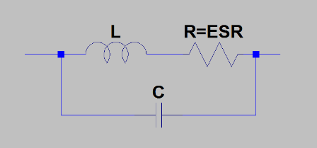

2: measured model parameters

Inductor: 15mH 2,5A AC

$$C1=\frac{1}{2*π*100kHz*{10}^{4}}=0,001µF$$

$$C2=\frac{1}{2*π*1MHz*600}=0,0026μF$$

$$Xl=ωL, L=\frac{Xl}{2πf}, C=\frac{1}{ωXc}, C=1/2πfC$$

$$L1=\frac{9}{2*π*100Hz}≈14mH$$

$$L2=\frac{90}{2*π*1kHz}≈14mH$$

$$L3=\frac{10000}{2*π*100kHz}≈15mH$$

Capacitor: 3,300uF 50V

$$L1=\frac{0,15}{2*π*100kHz{*10}^{5}}=0,2387μH$$

$$L2=\frac{1,5}{2*π*1,1MHz*{10}^{6}}=0,2387μH$$

$$C1=\frac{1}{2*π*100Hz*0,5}=3,183μF \\ C1=\frac{1}{2*π*1kHz*0,5}=2,652μF$$

$$Rs=0,025Ω$$

3: plot of impedance Z=f(Hz): include amplitude and angle plot as function of frequency on a logarithmic scale.

Inductor: 15mH 2,5A AC

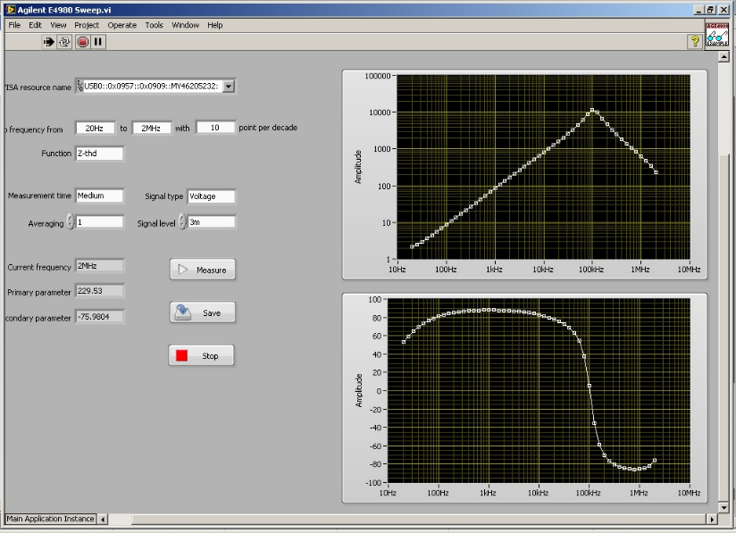

Capacitor: 3300uF 50V

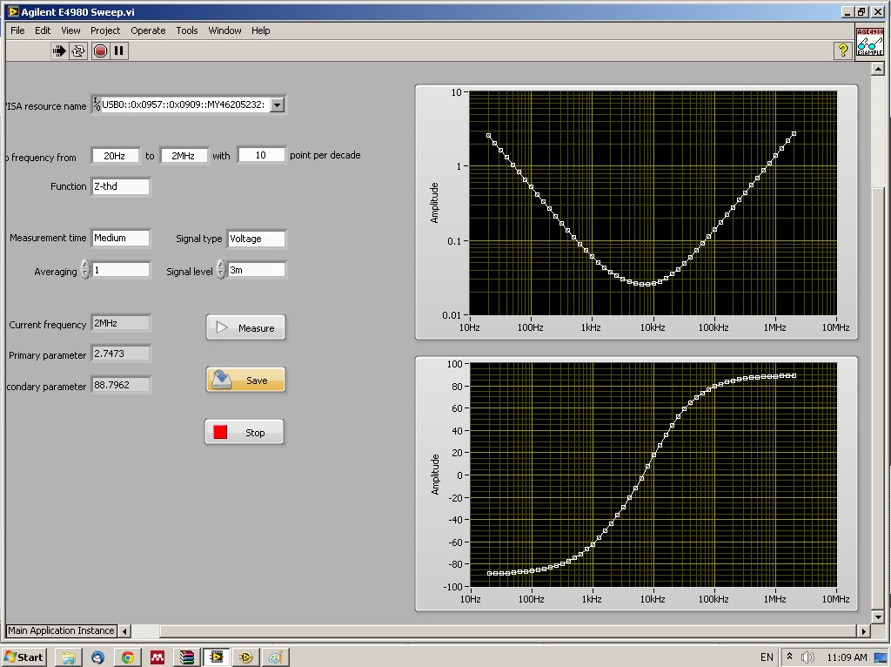

4: picture of capacitor and inductor

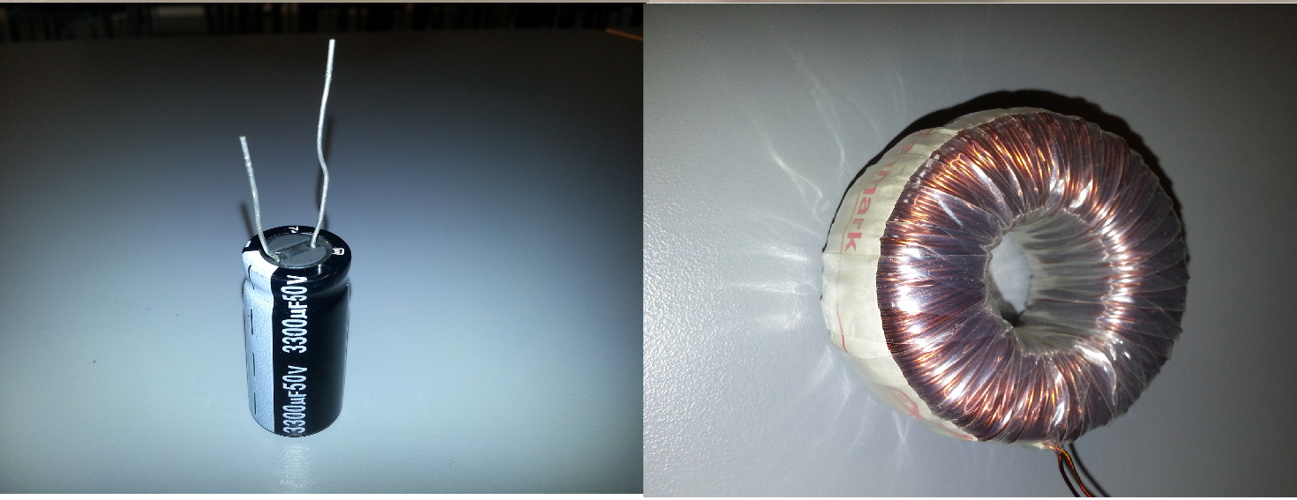

5: picture of measurement setup

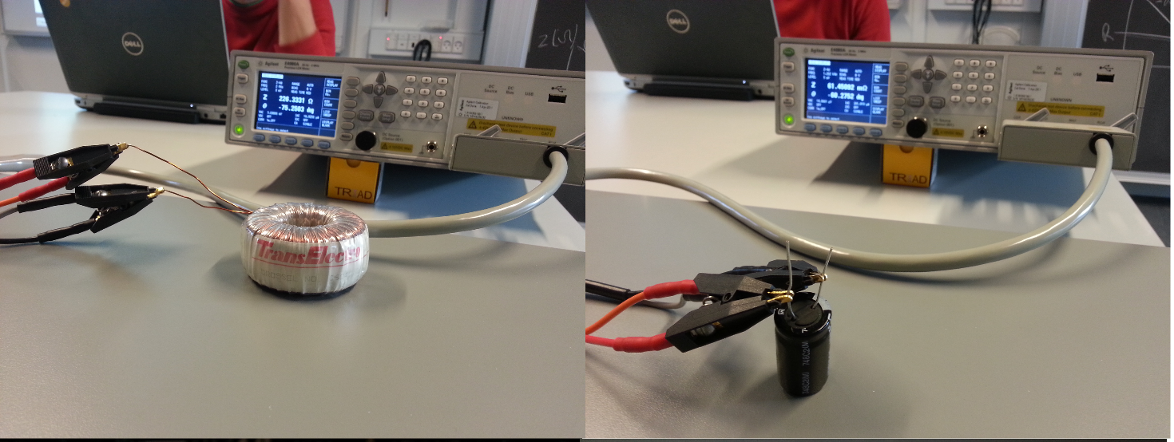

6: type of instruments used

Precision LCR Meter

Agilent E4980A, 20 Hz to 2 MHz

Capacitor:

748C2(M)

3300uF, 50V

Inductor:

Trans Electro

Drossel no.6604

Prod.9102

15mH, 2,5A AC